Date: 06.12.2024
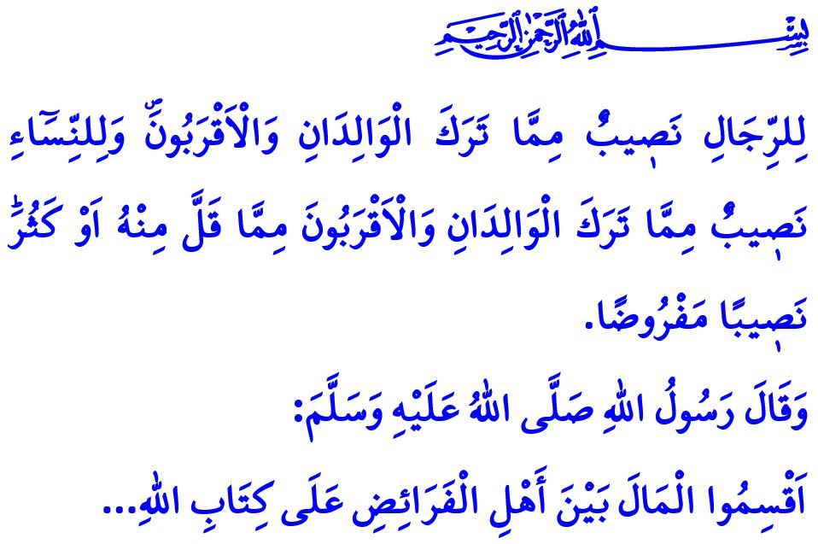
INHERITANCE: A RIGHT DEFINED BY THE BOUNDARIES SET BY ALLAH
Dear Muslims!
One of the key responsibilities emphasized by our sublime religion, Islam, is to distribute inheritance in accordance with the directives of Allah (swt) and His Messenger (saw). Inheritance refers to the distribution of the assets, property, and wealth left behind by a deceased individual among their heirs, as prescribed within specific boundaries.
In the Holy Qur’an, the rules regarding inheritance are outlined in precise detail and are referred to as ‘Hudud al-Allah’—the limits set by Allah (swt). Our Prophet (saw) says, “Distribute the property amongst Ahl al-Fara’id, according to the Book of Allah...”, emphasizing that no heir should be deprived of their rightful share in the inheritance.
Dear Believers!
Our religion, Islam, commands us to uphold justice with utmost care in all aspects of life, including the division of inheritance, and give every rightful individual their due share—whether man or woman, young or old—without discrimination. In this regard, our Lord Almighty (swt) states in the seventh verse of Surah al-Nisa, “For men there is a share in what their parents and close relatives leave, and for women there is a share in what their parents and close relatives leave —whether it is little or much. ˹These are˺ obligatory shares.” Moreover, Islam never marginalizes women in matters of inheritance, and ensures that women receive their rightful shares from their parents, spouses, children, and even grandchildren when applicable. Islam also acknowledges the legitimacy of heirs dividing the inheritance among themselves in any manner they agree upon, provided it is based on mutual consent.
Dear Muslims!
Today, injustices in the distribution of inheritance have become a significant cause of family disputes, fostering resentment among siblings and relatives, and often leading to conflicts and discord. However, failing to follow the guidelines set by Islam in the division of inheritance is a grave sin and a serious responsibility. Denying daughters their full rights, depriving them of inheritance because they are married, or deeming them only worthy of insignificant properties and lands that no other heir desires is a blatant act of injustice. As stated in the verse, usurping the inheritance rights of orphans is akin to filling one’s stomach with fire. A person may divide their property among their children, as long as they do so with fairness and without deviating from justice. It is a clear deviation from justice to give all or part of the inheritance to one child while neglecting the rights of the others. In this regard, the Prophet (saw) says, اِتَّقُوا اللّٰهَ وَاعْدِلُوا فِى أَوْلاَدِكُمْ “Fear Allah and observe equity in case of your children.”
Esteemed Believers!
Like all the rules set by Allah, the guidelines for the division of inheritance are perfectly suited to human nature. The only way to eliminate the issues and injustices in inheritance distribution today is by faithfully adhering to the principle of justice established by Islam.
Dear Muslims!
In the Holy Qur’an, the severe consequence for those who commit injustice in the division of inheritance is foretold as follows: “But whoever disobeys Allah and His Messenger and exceeds their limits will be cast into Hell, to stay there forever. And they will suffer a humiliating punishment.” Therefore, let us never violate the boundaries set by our Almighty Lord (swt) regarding inheritance, lest we be deceived by temporary worldly gains and consumed by our own ambitions. Let us give every rightful person their due, and never violate wtheir rights. Let us uphold compassion and fairness, mercy and justice, in the division of inheritance. Let us not forget that those who reject our Lord’s (swt) prescribed distribution of inheritance and seek more than their rightful share will face disappointment in this world and a humiliating punishment in the Hereafter.
I would like to conclude this Friday’s khutbah with our Prophet’s (saw) following warning: “One should not take a span of land without having legitimate right to it. Otherwise, Allah would make him wear (around his neck) seven earths on the Day of Resurrection.”

Muslim, Fara’id, 4.
Nisa, 4/7.
Nisa, 4/11; Daraqutni, Sunan, 5/160-161.
Nisa, 4/10.
Muslim, Hiba, 13.
Nisa, 4/14.
Muslim, Musaqah, 141. General Directorate of Religious Services

